# H1B –US visa interview questions.

Good Morning officer  
**Good morning How are you?**

I am doing good, thank you, how are you officer?

* **Please pass your passport and documents?** **Or** **Can I see your passport and petition?**  
  Yeah sure Officer, Here it is.  
    
  **why you are going to Us/ What purpose you are going to US?**  
  For employment purpose I am going to US, I will be work for Heli Consulting LLC(Limited Liability companies) as software developer.

**Why you want to work in US?**  
Global exposure and career growth in terms of advanced technologies and work culture.. I believe this opportunity will definitely help to advance my career.

**When was your passport issued?**

My passport was issued on 18th Oct 2021,

and old one was issued on 8th Nov 2013

first passport was issued on 05th Jan 2004

**Are you planning to return to India?**

Yes, Officer, this is temporary assignment for about 3 years, I will be come back to India once the contract is over.

**Why would you come back to India?**

I would need to take care of my parents and my kids are studying in India as well,

**What you will do after coming back to India?**

I will continue to work as software developer

**Why can’t your wife join with you now?**

I have 2 kids, one is 6 years old and another one is10 years old. They are studying in india, I don't want to disturb their education and also my wife need to take care of my parents as well.

**Have you ever applied for any visa for other country? Or Have you ever travelled outside of the India?**

Yes, officer, I have work permit for Malaysia and been working for Maybank.

**Current Employer / Prior Experience**

**Which company do you currently working for ?**   
I am working for Maybank as a senior developer

**what are you doing in Malaysia?**  
I am working for Maybank as a senior developer, Here I have involved in Retail Hire Purchase and Regional branch solution projects. it’s a bank teller applications who provide the vehicle loans, cash withdrawal and deposits, remittance at the bank.  
**For how long you have been for working for this company?**

9 years and 6 months

**What are your current job role and responsibilities?**

My role is a senior developer for Maybank company.

My responsibilities are like

Requirement analysis, design and develop the applications by using the Java technologies

develop the reused components in the application by using the react Js,

Design and develop Red Hat workflows …that support business application process

production support,

trained and mentor for new developers,

code review,

prepare the technical documentation for each releases

and provide the db scripts for the production release.

**Your current company is excellent, then why are you leaving it?**

Global exposure and career growth in terms of advanced technologies and work culture. I believe this opportunity will definitely help to advance my career.

I got a opportunity to expertise in advanced technologies like cloud, devops, and data science.

# **Sponsor Company / H1B Employers**

**Who is your Employer/ to whom you are going to work? Who is your petitioner? What is your employer name?**Heli Consulting LLC(Limited Liability companies)

**Where is the company located? Or Can you tell full location?**  
4425 W Airport Freeway, Suite 364, Irving City, Texas state – 75062  
**What your employer will do?**Heli Consulting provides the IT consulting services, Staff Augmentation services  
and software development business.

**Tell me more about your employer?**Heli Consulting is based out of Irving city, Texas State, and is engaged in the business of IT Consulting Services, Application Development Services, Integration Services, Maintenance/Support Services.

The Company’s technological focus is in the areas of Artificial Intelligence, Data Science, Big Data, Multi-Platform Integration.

And my employer has few clients which are Gordon Food Services, Dean Health Systems, Amex, Paypal, JP Morgan.

**In US where you will work?**  
I will be work at my employer’s location which is 4425 W Airport Freeway, Suite 364, Irving City, Texas state – 75062

vendor location is : 42450 Hayes road, Suite #3,Clinton Township city, Michigan, 48038, United States

client location- GRAND RAPIDS CITY, MICHIGAN STATE

CEO – LIZ BUTTS

**How many rounds of interview you had?**I had 2 technical discussions and followed by 1 HR round.

**When was the interview conducted?**

1st technical round had done on 14th Jan 2022

Second technical round had done on 18th Jan 2022

HR round had done on 20th Jan 2022

**How was the interview conducted? (Over the phone or skype)**

It was conducted on zoom

**who interviewed you?  
Who has done the Interview?**

There were 3 rounds of interview –

First technical round has done by Rama Krishna.  
And second technical round had done by drew setterley and rama Krishna

And Hr round had done by Monohar V **Who is your HR ?**

Manohar V **What they asked in the interview ?**There were 3 rounds of interview -   
In the first technical round - they asked about current project and previous project architectures and technologies.   
And in the second technical interview – they tested my skills in Java and Spring boot Micro Services.   
And in HR round – they asked general questions like salaries and current company notice period and etc.

**How do you interact with your client?**  
On Zoom meetings

**Who is your client supervisor?**  
Drew Setterley

**Do you have client, who is your client?**  
Yes officer, Gordon Food Services

**What you will do for your Employer? What kind of work you will do there? Or What are your roles and responsibilities?** OR **What Will You Work As At The Aforementioned Company**

My role is a software developer for Heli consulting LLC.

My job responsibilities are like

Design the client-side and server side architecture for the application,

Develop the new API’s for sending and receiving the data from the external interface by using spring boot micro services,

Build the front end application by using the React JS.

Requirement analysis, design and develop the application by using the java technologies,

Prepare the technical documentation for enhancements.

Production Support,

And provide the non-functional requirement support like improve scalability, usability, security for the application by using Docker and kubernates platforms

**What is your salary in US?**95000 USD per year

**What is your salary and any bsenefits?**

95000 USD per year, I will have medical insurance benefits, annual vacation and relocation allowances

**How long you will work in US?   
How long are you planning to stay in US ?**  
My contract with employer is 3 years, I will be come back to India once the contract is over.

**How many Employees are there in your US Company?  
What is the size of US employer/Company?**  
10 employers are working

**How did you come to know about this US Employer? or How do you know about this Employer? How did you find this job?**Through the reference. my friend suggested me to upload profile in Heli consulting web site. they verified my profile and conducted the interview through zoom call.

**How did you contact your sponsoring employer during your job search?**

I uploaded my profile in Heli consulting website, they verified my profile and conducted the interview through zoom call.

**Have you verified whether your company is a legitmate company in USA? How do u know?**

Yes Officer, I verified in the myvisajobs.com site and also my employer was presented their ‘Good Standing Certificate’ for my clarification

**What is the annual turnover of your US employer?**

Heli consulting LLc company is newly established in 2021, my employer had provided the tax returns and 2021 W2 letters for my reference. Here it is.

**Do you know the name of the president of your sponsoring company employer ?**

Naga Jyoti kandibanda

Who are the clients of your company?

Gordon Food Services, Dean Health Systems, Amex, Paypal, JP Morgan

Are you going to work onsite at a client’s location?

No officer, I will work at employer location and remotely support to the client project.

Can you explain your project in brief?

**I will work for Gordon Food Delivery System** (**GFDS**) project, it is a [food service distributor](https://en.wikipedia.org/wiki/Foodservice_distributor) ,is based in [Michigan](https://en.wikipedia.org/wiki/Wyoming,_Michigan) , it is serving the Midwest, Northeast and Southeast regions of the United States.

Main delivery products are dairy, grocery& bakery, seafood, meats and commercial kitchen equipment.

My role in this project is a software developesr.

My job responsibilities are like

Design the client-side and server side architecture for the application,

Develop the new API’s for sending and receiving the data from the external interface

Gordon food services was established by Liz butts in 1897.. around 10 thousand people are working from this organization. There are 170 Gordon food service stores available across the U.S

How will you manage your expenses before u get your first pay check?

My employer will provide the initial accommodations. and for other expenditures I do have savings from my earnings, will convert into USD dollars and utilize it till I get the salary.

After the conclusion of your visa , what do you plan to do?

I will come back to India once my contract is over and will continue to work as a software developer in India.

Do you have any proof from your new employer regarding your responsibilities?

Yes officer, My responsibilities are listed in the employment letters.

Are there any middle vendors between your Employer and Client.  
Yes officer, JRD systems inc.

JRD Systems was founded by Jai Reddy in 2001, it is located in Clinton Township, Michigan.

JRD Systems is providing IT Consulting, Maintenance and support Services and Technology Solutions

The Industries which they involved in Healthcare, Administrative, Professional, and Engineering,

Don’t you have letter from Client.

I have the MSA letter from Vendor, Here it is

* How do you report to your employer? –

Since they are following the agile methodologies having daily stand-up meetings, all the team members should update what have done yesterday and what we do today in that stand-up meeting.

From when you are working with the US employer?

10th Feb 2023

When you got the offer letter from employer.?

6th May 2022

Employer policies?

Yes officer, I gone through policies from the employer hand book like

Internet, Email and Computer Use Policy.

Full time and part time policy

Cell Phone Policy.

Social Media Policy.

Exempt Employees for Federal Labor Standards Act and texas state law

Personnel Records and Employee References,

Immigration Law Compliance

Should serve for 2 weeks after resignation

Vendor operational manager

Sarah Lafriniere

**List of Documents which I carried for H1B Visa Stamping Appointment:**—————————————————  
1. I797 Approval Original Document  
2. Passport  
3. LCA  
4. I129 Photocopy  
5. Letter from Vendor stating Client Name, Project Description, Roles and Duration of the Project  
6. Copy of MSA Letter between my employer and vendor.  
7. Copy of 2012 W2s  
8. Copy of 2012 Federal/State Tax documents.  
9. Paystubs for last one year.  
10. Employment Verification Letter.  
11. Experience Letter from Previous Employer.  
12. Degree Certificate  
13. Semester Mark sheets  
14. Client Supervisor’s Name, Work email id, Phone Number.  
15. My Client ID Card.

A **certified authorization professional** (CAP)

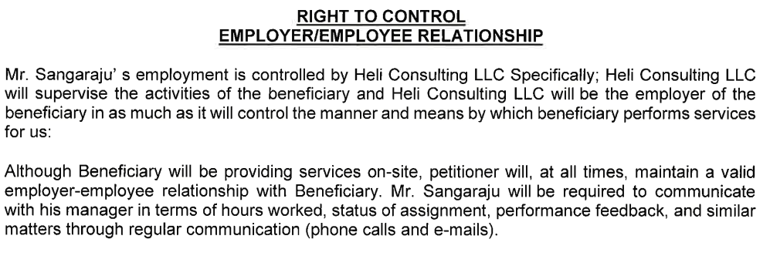

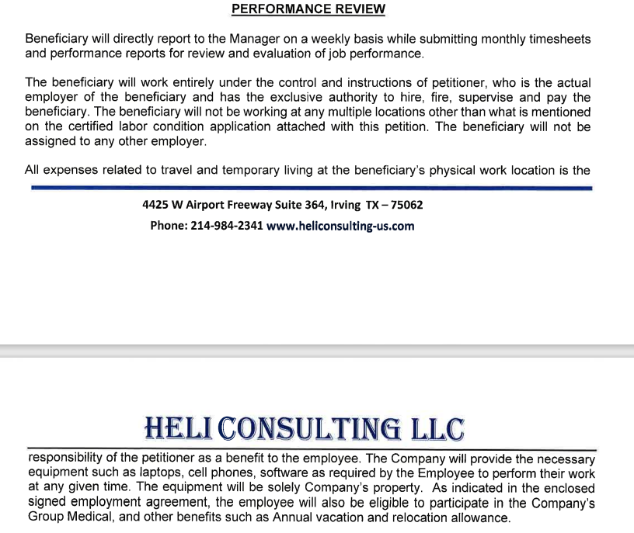

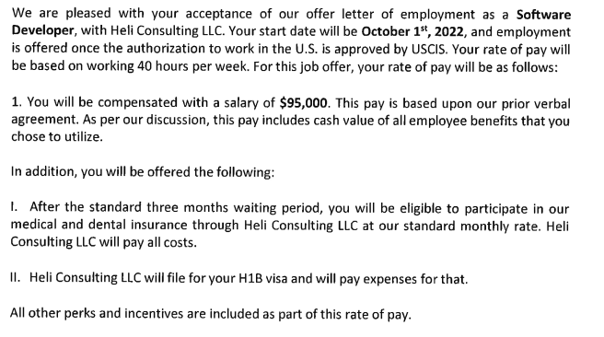

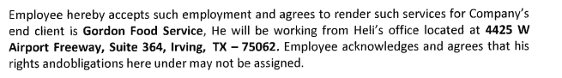

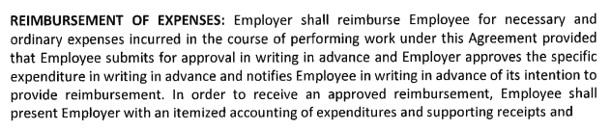

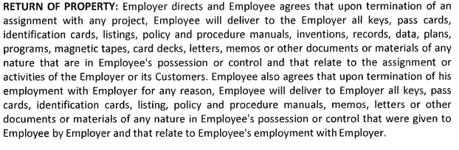

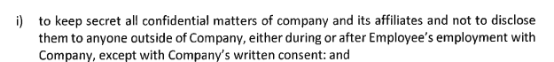

Midest – Indiana, Michigan

Southest – florida, Georgia

Northest – New York, jersey

Texas – culture wise it is in west cost – geographically it is in central timezone

Texas population is 29 million and second highest population in us after California

Geographically second largest with an area of 2 lakh 68 square miles

Texas is one of the hottest states  
**In texas famous is BBQ, Foot ball**

**Beautiful cities over there, houston, Austin,dallas,fort worth,Fredericksburg**

**Irving is a great place to live, work, and** Irving is famous for being the international headquarters and several excellent museums.

254,198 population

**Is this your first passport?**

No, this is my 3rd passport

**Have you ever been to the U.S?**

No Officer

**Have you ever been here (to the consulate) before?**

No Officer, this is first time.

**How long have you been married?**

11 years

**Do you have family in U.S?**

No officer. I don't have family in USA

**Have you ever applied for any Immigrant/Non Immigrant visa for USA earlier?**

No Officer

**Can I see your master thesis?**

Sure officer, here it is

**Did you do any part of this thesis in off campus?**

No, officer, I have done this mini project in on campus itself during my 4th semister.

**What was the subject of this thesis?**

The project name is traffic signals captured by images, we developed this project by using the Java technologies. Capturing the traffic jam images and storing in to the database system. And fetching those images and keep sending to the traffic controlling systems to control the traffic.

**Can I see your degree certificates?**

Yes, Officer, Here it is

**Can I see the experience letters?**

Yeah sure, here it is

Can I see the job offer letter?

Yeah, Sure, here you are

Can I see your LCA (Laber condition Application form sponsoring employer) and your latest salary payslips(pay stub) from your current employer?

Yeah, Sure, here you are

What kind of projects does your US employer engage in?

I am not sure at this time, but they have few clients which are Gordon food services, dean health systems, amex, paypall, JP Morgan.

Who designed the project?

I am not sure at this time officer.

Will they sell this project?

I am not sure at this time officer

Can I see the tax documents?

Yes, officer,Here you are.

How many people from your company work for your client?

4 more along with me

Can I see the photographas of your company?

Yes, officer,Here you are

Can I see the Employee petition to USCIS and the Tax Returns of the Company?

Yes, Officer, Here it is.

You were holding any other visa before.  
Yes Officer, I have work permit for Malaysia.

Give me all the H1B petition document which your employer filed.  
(LCA and I129)

* When did you visit India last time?

In May 2022

Show me your bank statements

Yes officer, here it is

# **Qualifications?**

**What is your qualifications?**

Batchelor Degree and Master’s Degree in computer science

**Are you currently studying?**

No officer, I am Working for Maybank.

* **What was your major subject?**

Computer science, Java Programming language in computer science

**In which year and from which university did you get this degree?**

I completed Master of computer science in the year of 2007 in JNTU university located in Hyderabad, India.

**what’s your higher degree?** Master’s degree in computer science in JNTU university, India

**Did You Undertake Any Research Projects While Studying?**

Yes officer, traffic signal captured by images.

**Experience**

**How many total years of IT experience do you have?**

I have 14+ years of experience in the IT industry.

**since when are you working in the current company?**  
Here I have been working Since 2013.

**What is your current salary?**

(1,63000rm per annum) – 13,600 per month

What is your designation going to be in US company?

My designation is a Software developer and will work for Heli consulting LLC .

Do you know the average living cost in your city?

1500 to 2000 usd per month

Did you pay for your H1B petition related expenses?

No officer, my employer paid.

**Is this company founded by an Indian? are all employees Indian?**

Yes, Officer, Heli consulting llc company founded by an Indian. I am not sure at this time all employees are from India or not

**For how many years has your sponsoring employer been in business? Or For how many years has your company been operating from the location that you are going to work at?**

1 year

Can you show me the project documentation and your itinerary of your services there?

I do not have the project documentation at this time, Here I have the letter from Vendor, my responsibilities are listed in that vendor letter.

As per client policies they do not share directly to my employer at this time.

What’s your designation in [Previous Company] and what's your designation in the [New Company]?

Working for Maybank as senior developer and will work for Heli consulting llc as software developer.

Can you give me your 2021 W2 of H1B employer.?

Yes officer, here it is

What specialty skills that you acquired from this employer?

Full stack development experience by using the Java technologies

and knowledge on the cloud technologies,

automate deployment process.

Setup the application infrastructure

* What is your qualification for this job?

Master’s degree in the computer applications.

* Whom do you report to? What you will report to your employer?

Rama Krishna, since they are following the agile methodologies we will update the development status in the daily stand-up meetings

What are the technologies you are working on?

Java technologies are like react JS, spring boot micro services,

Database as oracle,

Red Hat workflows that support business application process.

Spring Data JPA,

Jboss as a application server.

Jenkins,

postman,

Jira